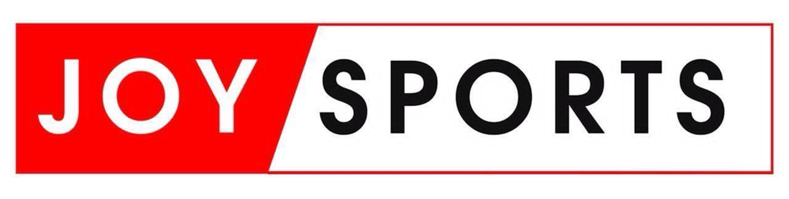

***INVITATIONAL FOOTBALL TOURNAMENT 2024 Edition***

***26th October, 2024 @ University of Ghana Stadium Legon***

**REGISTRATION FORM**

***(THIS FORM MUST BE COMPLETED IN DUPLICATE)***

Name of Company: ....................................................................................................................................

Description of Business: ............................................................................................................................

Contact person: ..........................................................................................................................................

Contact Numbers: .......................................................................................................................................

Email Address: ............................................................................................................................................

**TOURNAMENT GAMES TO BE PARTICIPATED**

* MALE SOCCER TOURNAMENT...................................YES......................NO
* FEMALE PENALTY SHOOT CONTEST.....................YES......................NO
* TABLE TENNIS......................................................................YES......................NO
* UNISEX RELAY...................................................................YES......................NO
* LAWN TENNIS......................................................................YES......................NO
* UNISEX BASKETBALL......................................................YES......................NO
* UNISEX SACK RACE...........................................................YES......................NO
* TAG OF PEACE……….......................................................YES.......................NO
* ARM WRESTLING.................................................................YES......................NO
* CEO‘s PENALTY SHOOT OUT.........................................YES..................... NO
* 5KM RACE WALK..............................................................YES......................NO
* MASTERS 50M DASH..........................................................YES......................NO
* WOMEN PENALTY SHOOT OUT…………………..YES………….. NO
* UNISEX LIME & SPOON RELAY………………… YES…………. NO
* SWIMMING...............................................................................YES...................NO

**TOTAL PARTICIPATION FEE GH¢ ……….**

**For and on behalf of JOY FM For and on behalf of CLIENT**

Name ……………………………… Name ………………………………

Title………………………………… Title…………………………………

Date………………………………… Date…………………………………

Signature……………………………. Signature…………………………….